AI-POWERED EMERGENCY RESPONSE
& CRISIS COORDINATION SYSTEM
For Hospitality Ecosystems

Project Requirement Document & Implementation Blueprint
Google Solution Challenge 2025–26
Version 1.0 | April 2026
CONFIDENTIAL

Table of Contents

Section 1 — Executive Summary
The hospitality industry serves billions of guests annually across hotels, resorts, cruise ships, airport lounges, convention centers, and large event venues. Despite significant investment in physical safety infrastructure, the sector remains critically underserved by intelligent digital emergency management systems. When crises strike—whether a fire, earthquake, active threat, or medical emergency—communication between guests, hotel staff, security teams, and external first responders fragments rapidly, leading to delayed response, confusion during evacuation, and preventable loss of life.
This Project Requirement Document presents the architecture and implementation blueprint for CrisisGuard AI, a comprehensive AI-powered emergency detection, alert, and coordination platform purpose-built for hospitality ecosystems. The platform leverages artificial intelligence, multimodal AI detection, real-time communication infrastructure, and cloud-native scalability to deliver a unified crisis management solution.

1.1 Vision Statement
To eliminate preventable deaths and injuries in hospitality environments by providing an intelligent, real-time emergency detection and coordination platform that connects every guest, staff member, and first responder within a unified crisis response ecosystem.

1.2 Core Value Proposition
- Instant Detection: AI-driven analysis of CCTV feeds, audio streams, and multimodal inputs (text, voice, image) to detect emergencies within seconds, before human operators even become aware.
- One-Tap SOS: Guests can trigger emergency alerts with a single tap or voice command, eliminating the delay of finding phones, calling front desks, or locating manual fire alarms.
- Coordinated Response: Real-time synchronization between on-property staff, security teams, property management, and external emergency services through a unified command center.
- Intelligent Evacuation: AI-generated evacuation routes that dynamically adapt to the specific nature and location of the emergency, guiding guests to safety via their mobile devices.
- Scalable Architecture: Cloud-native design capable of supporting 1,000+ properties and 1,000,000+ concurrent users across geographically distributed hospitality portfolios.

1.3 Target Impact
According to the National Fire Protection Association, hotels and motels experience an average of 3,520 structure fires per year in the United States alone. The World Health Organization reports that uncoordinated emergency response is a leading contributor to preventable casualties in large-occupancy buildings. CrisisGuard AI directly addresses these statistics by reducing average emergency response time from 8–12 minutes to under 90 seconds, and by providing every occupant with personalized, real-time evacuation guidance.

Section 2 — Problem Analysis
Emergency management in hospitality venues suffers from systemic failures rooted in fragmented communication, manual detection processes, and the absence of intelligent coordination systems. This section analyzes the core failure modes through real-world scenario analysis.

2.1 Hotel Fire Scenario
When a fire breaks out on the 14th floor of a 300-room hotel, the traditional response chain is dangerously slow. Smoke detectors trigger the building alarm system, but the alarm provides no information about the fire’s location, severity, or recommended evacuation route. Guests on upper floors may attempt to use elevators, descend toward the fire floor, or remain in their rooms uncertain of the threat level. Hotel staff rely on walkie-talkies and phone trees to coordinate, creating communication bottlenecks. The fire department receives a generic alarm notification with no situational intelligence about the building layout, guest locations, or the fire’s progression.
With CrisisGuard AI, CCTV-based fire detection triggers within 8 seconds. Every guest receives a push notification with floor-specific evacuation instructions. The command center sees a real-time heatmap of guest locations. First responders receive building blueprints, fire location data, and occupancy information before they arrive on scene.

2.2 Medical Emergency Scenario
A guest experiencing cardiac arrest in a resort pool area faces critical time pressure—brain damage begins within 4–6 minutes without intervention. In conventional systems, a bystander must locate a staff member, who must then call a manager, who contacts local emergency medical services. This relay chain consumes precious minutes. Additionally, the location of the nearest AED (Automated External Defibrillator) may be unknown to nearby staff.
CrisisGuard AI allows any guest or staff member to trigger a medical SOS that instantly dispatches the nearest trained first-aid responder, displays the AED location on the responder’s device, and simultaneously contacts ambulance services with GPS coordinates and preliminary incident details.

2.3 Terrorist Threat Scenario
Active threat situations in crowded hospitality venues—such as the 2008 Mumbai hotel attacks or the 2017 Las Vegas shooting—demonstrate the catastrophic consequences of communication failure. Guests receive no digital guidance, staff have no centralized intelligence, and law enforcement arrives without real-time situational awareness.
CrisisGuard AI’s anomaly detection system can identify suspicious behavior patterns through CCTV analysis, trigger silent alerts to security teams, initiate lockdown protocols, and provide law enforcement with live video feeds, guest location data, and building access point status—all within seconds of threat detection.

2.4 Earthquake Evacuation Scenario
Earthquakes provide no advance warning and demand immediate, coordinated evacuation. In large convention centers or cruise ships, guests are unfamiliar with the building layout and may have no knowledge of assembly points. Traditional PA systems may fail due to power loss, and printed evacuation maps become useless when structural damage blocks designated routes.
CrisisGuard AI’s offline-capable mobile app provides GPS-independent indoor positioning, dynamically reroutes evacuation paths based on AI-analyzed environmental data, and operates on cached maps even without network connectivity. The system’s mesh networking fallback ensures device-to-device alert propagation when cellular infrastructure is compromised.

2.5 Root Cause Summary
Failure Mode | Root Cause | CrisisGuard AI Solution
Delayed detection | Manual observation dependency | AI-powered CCTV and multimodal analysis
Communication breakdown | Fragmented walkie-talkie/phone systems | Unified real-time digital command center
Guest confusion | Generic alarms with no guidance | Personalized push notifications with evacuation routes
Poor coordination | No shared situational awareness | Live incident dashboard with role-based access
Slow first responder dispatch | Manual 911 calls with limited info | Automated dispatch with rich contextual data

Section 3 — Solution Overview
CrisisGuard AI is a full-stack, cloud-native emergency response platform composed of three primary interface layers, an intelligent backend core, and a distributed AI processing pipeline. The platform operates across three user roles—Guest, Staff/Security, and Admin/Command Center—each with purpose-built interfaces optimized for crisis scenarios.

3.1 Platform Architecture Overview
The system follows a microservices architecture deployed on Google Cloud Platform, with event-driven communication between services. The architecture is organized into five functional layers:
- Presentation Layer: Flutter-based mobile applications for guests and staff, React/Next.js admin dashboard for command center operations.
- API Gateway Layer: Cloud-managed API gateway handling authentication, rate limiting, request routing, and load balancing across backend services.
- Application Services Layer: Containerized microservices handling alert processing, user management, incident coordination, notification dispatch, and analytics.
- AI/ML Processing Layer: Dedicated GPU-accelerated services for multimodal emergency detection (CCTV vision, audio panic detection, text/NLP analysis), Generative AI crisis assistant inference, AI incident summarization, and anomaly detection running on Google Vertex AI.
- Data & Infrastructure Layer: Multi-model database architecture using Firebase Firestore for real-time data, PostgreSQL for relational analytics, and Redis for caching and pub/sub messaging.

3.2 Emergency Alert Flow
The core value of the platform lies in its sub-second alert pipeline. When an emergency is detected—whether by AI systems, staff reports, or guest-initiated SOS—the following sequence executes:
- Emergency event is detected or triggered (AI detection, multimodal alert, or guest SOS).
- Alert ingestion service validates the event, assigns severity classification, and generates a unique incident ID.
- Notification dispatcher simultaneously pushes alerts to all relevant staff devices, the admin command center, and queues external emergency service notifications.
- Incident coordination service creates a response workflow, assigns tasks to nearest available staff, and opens a dedicated communication channel.
- Evacuation guidance engine calculates optimal routes based on emergency type and location, pushing personalized instructions to all guest devices in the affected zone.
- Real-time tracking service begins monitoring guest and staff locations, updating the command center heatmap.
- Post-incident analytics service begins logging all actions, communications, and response metrics for after-action review.

3.3 Multi-Venue Support
CrisisGuard AI is designed as a multi-tenant platform supporting diverse hospitality venue types. Each property is configured with its own floor plans, AI camera integrations, staff roster, evacuation routes, and emergency service contacts. The platform supports hierarchical management where a hotel chain’s corporate office can monitor all properties through a unified portfolio dashboard while individual property managers retain full operational control.

Section 4 — System Architecture

4.1 Frontend Architecture

4.1.1 Guest Mobile Application (Flutter)
The guest application is built with Flutter for cross-platform deployment on iOS and Android from a single codebase. The app uses the BLoC (Business Logic Component) pattern for state management, ensuring separation of concerns between UI rendering and business logic. Key architectural decisions include offline-first data caching using Hive local database, background service workers for receiving push notifications even when the app is closed, and WebSocket connections for real-time updates during active incidents.

4.1.2 Staff Mobile Application (Flutter)
The staff application shares the Flutter codebase with the guest app but presents a role-specific interface. It includes persistent WebSocket connections for instant alert delivery, background location sharing during active incidents, and integration with the property’s existing PMS (Property Management System) for guest room assignments and occupancy data.

4.1.3 Admin Command Center (React/Next.js)
The web-based command center is built with Next.js for server-side rendering and optimal performance. It uses React with TypeScript for type-safe component development, Zustand for lightweight state management, and Socket.IO client for real-time dashboard updates. The dashboard features a responsive grid layout that adapts between monitoring mode (passive observation) and crisis mode (active incident management) with distinct visual hierarchies.

4.2 Backend Architecture
The backend follows a microservices architecture with each service independently deployable and scalable. Services communicate through a combination of synchronous REST/gRPC calls for request-response patterns and asynchronous message queues (Google Cloud Pub/Sub) for event-driven workflows.

4.2.1 Core Microservices
Service | Technology | Responsibility
Auth Service | Node.js + Firebase Auth | User registration, login, JWT token management, role-based access control
Alert Ingestion Service | FastAPI (Python) | Receives and validates emergency alerts from all sources, assigns severity, routes to dispatcher
Notification Service | Node.js | Multi-channel notification dispatch via FCM, SMS (Twilio), email, and WebSocket
Incident Coordinator | Node.js | Manages incident lifecycle, task assignment, staff dispatch, escalation workflows
Evacuation Engine | Python + NetworkX | Calculates optimal evacuation routes using graph algorithms on building floor plans
AI Gateway | FastAPI (Python) | Routes multimodal AI requests to Vertex AI for vision, audio, NLP, incident summarization, and Gemini inference
Analytics Service | Python + Pandas | Aggregates incident data, generates reports, computes response time metrics
Location Service | Node.js | Processes and stores real-time location updates from guest and staff devices

4.3 Cloud Infrastructure
The entire platform is deployed on Google Cloud Platform (GCP) leveraging managed services for reliability and scalability:
- Google Kubernetes Engine (GKE): Hosts all containerized microservices with auto-scaling based on CPU, memory, and custom metrics (active incident count).
- Cloud Run: Serves stateless AI inference endpoints with scale-to-zero capability for cost optimization during non-emergency periods.
- Cloud Pub/Sub: Provides the event bus for asynchronous inter-service communication with guaranteed at-least-once delivery.
- Cloud CDN + Load Balancer: Distributes static assets and API traffic across global edge locations with health-check-based failover.
- Cloud SQL (PostgreSQL): Managed relational database with automated backups, point-in-time recovery, and read replicas for analytics queries.
- Firebase Firestore: Real-time NoSQL database for live incident data, user presence, and device state synchronization.
- Cloud Storage: Stores CCTV snapshots, incident recordings, floor plan assets, and audit logs with configurable retention policies.

4.4 Multimodal AI Detection Architecture [NEW — 2025–26]
CrisisGuard AI replaces traditional IoT sensor dependency with a fully software-driven, multimodal AI detection layer. Instead of relying on proprietary hardware sensors and MQTT gateways, the platform processes emergency signals through three AI modalities operating in parallel:
- Visual AI (Image/Video): Real-time CCTV frame analysis using Vertex AI Vision and custom YOLOv8 models for fire, smoke, crowd panic, weapon detection, and anomalous behavior recognition. Guests can also submit photos via the app for AI-powered incident classification.
- Audio AI (Voice/Sound): AI panic detection from ambient audio streams and voice-activated SOS through on-device keyword spotting. Distress sounds (screams, glass breaking, gunshots) are classified using spectrogram-based CNNs without recording raw audio, preserving privacy.
- Text AI (NLP/Chat): Generative AI emergency assistant powered by Gemini analyzes guest chat messages, social media mentions, and staff reports for emergency intent classification, extracting location, severity, and urgency in 40+ languages via multilingual AI support.
This software-first approach eliminates hardware procurement costs, simplifies deployment to new properties (no physical installation required), and leverages existing CCTV infrastructure that is already present in virtually all hospitality venues.

Section 5 — Technology Stack
The technology stack is selected for reliability under crisis conditions, developer productivity, and alignment with Google Cloud ecosystem for Solution Challenge compatibility.
Layer | Technology | Justification
Mobile Apps | Flutter 3.x + Dart | Single codebase for iOS/Android, excellent performance, rich widget library, offline support
Admin Dashboard | Next.js 14 + React 18 + TypeScript | Server-side rendering for fast initial load, type safety, rich ecosystem
Backend API | Node.js 20 (Express) + FastAPI (Python) | Node.js for I/O-bound services, FastAPI for AI/ML pipeline integration
Real-Time Engine | Socket.IO + Firebase Realtime DB | Low-latency bidirectional communication, native mobile SDK support
Primary Database | Firebase Firestore | Real-time sync, offline persistence, automatic scaling, serverless
Analytics Database | PostgreSQL 16 (Cloud SQL) | Complex queries, joins, window functions for incident analytics
Cache Layer | Redis (Memorystore) | Sub-millisecond response for location data, session management, rate limiting
Message Queue | Google Cloud Pub/Sub | Managed, scalable event bus with guaranteed delivery and dead-letter queues
AI/ML Platform | Google Vertex AI | Managed ML infrastructure, AutoML, custom model deployment, prediction endpoints
Computer Vision | Vision AI + Custom TensorFlow | Pre-trained object/fire detection plus custom models for anomaly patterns
Speech Processing | Google Speech-to-Text API | Real-time streaming recognition, 125+ languages, noise robustness
NLP / Chatbot | Gemini 2.0 + Vertex AI + RAG | Generative AI with RAG, multimodal input (text/voice/image), 40+ languages
Maps & Location | Google Maps Platform | Indoor maps, Places API, Directions API, Geofencing
Push Notifications | Firebase Cloud Messaging (FCM) | Cross-platform delivery, topic-based broadcasting, priority channels
SMS Fallback | Twilio API | Reliable SMS delivery when app notifications fail, international coverage
Authentication | Firebase Authentication | OAuth 2.0, phone auth, anonymous auth for guests, custom claims for RBAC
CI/CD | Cloud Build + Artifact Registry | Automated build, test, and deploy pipelines with container scanning
Monitoring | Cloud Monitoring + Cloud Logging | Infrastructure metrics, application logs, custom alerting policies
Container Orchestration | Google Kubernetes Engine (GKE) | Auto-scaling, rolling deployments, service mesh with Istio

Section 6 — User Role Design

6.1 Guest Role
Guests represent the primary protected population. Their interaction with the system is designed to be zero-learning-curve, requiring no training or onboarding. The guest role supports three interaction modes:

6.1.1 Passive Mode (Normal Operations)
During normal operations, the guest app runs silently in the background. It maintains a persistent connection to the notification service and periodically updates the guest’s indoor location using BLE beacon triangulation. The app’s home screen displays the property’s emergency contact number, nearby safety equipment locations, and a prominent SOS button. No action is required from the guest.

6.1.2 Alert Mode (Emergency Detected)
When an emergency is detected, the app transitions to alert mode. The screen changes to a high-contrast emergency interface with large text and simple icons. The guest receives a push notification with the emergency type and initial instructions. The app displays a real-time evacuation map with a highlighted route from the guest’s current location to the nearest safe assembly point. Turn-by-turn navigation with distance estimates guides the guest through the evacuation. The AI chatbot becomes available for voice and text queries about the situation.

6.1.3 SOS Mode (Guest-Initiated)
Guests can initiate an SOS through three methods: one-tap SOS button (single press for general emergency, long press for silent alert), voice-activated SOS by saying a configurable trigger phrase detected by the app’s always-listening module, or chatbot interaction describing the emergency situation. Each SOS submission captures the guest’s GPS/indoor location, timestamp, device battery level, and optional photo/video attachment.

6.2 Staff / Security Role
Staff members are the first line of response. Their app is designed for rapid situational awareness and action execution under stress.

6.2.1 Shift Start Workflow
Upon clocking in, staff members open the CrisisGuard app and check in to their assigned zone. The system registers their location, role (front desk, housekeeping, security, maintenance, medical), and current availability status. This data feeds the incident coordinator’s dispatch algorithm.

6.2.2 Alert Response Workflow
When an incident is created, the nearest qualified staff members receive prioritized alerts with a 15-second acknowledgment timer. If unacknowledged, the alert escalates to the next nearest staff member. Upon acknowledgment, the staff member receives the incident location on their map, assigned tasks (e.g., “Evacuate Floor 14, Rooms 1401–1420”), a communication channel connecting them with other responders, and real-time updates from the command center. Staff can update their task status (en route, on scene, task complete) which feeds the command center’s tracking dashboard.

6.3 Admin / Command Center Role
Administrators operate the web-based command center, providing strategic oversight and coordination during crises.

6.3.1 Monitoring Mode
During normal operations, the dashboard displays a property overview with real-time occupancy, staff deployment map, system health status (AI pipeline status, camera connectivity), and historical incident analytics. Administrators can configure alert thresholds, manage staff roles, update floor plans, and run emergency drill simulations.

6.3.2 Crisis Mode
When an incident is activated, the dashboard transforms into a crisis management interface featuring a live incident feed with chronological event log, building heatmap showing guest and staff locations color-coded by status, communication hub with channels for each active response team, resource tracker showing deployed staff, available responders, and external service ETAs, and a decision support panel with AI-generated recommendations based on incident type and severity.

Section 7 — Mobile App Features (Guest)

7.1 SOS Emergency Button
The SOS button is the app’s most critical UI element. It occupies a fixed position at the bottom center of every screen, rendered as a large circular button with a pulsing red glow animation. Design specifications: minimum touch target of 72x72dp (exceeding accessibility guidelines), haptic feedback on press, 3-second long press for silent alert mode, and confirmation vibration pattern on successful transmission. The button functions even when the phone is locked via a persistent notification widget.

7.1B Guest “Panic Triage” Dashboard [NEW — SIGNATURE FEATURE]
The Panic Triage Dashboard is the guest’s primary crisis interface, designed for extreme-stress scenarios where cognitive capacity is severely reduced. The moment a guest opens the emergency section of the CrisisGuard app, they see three oversized, color-coded buttons on a dark-mode background: FIRE (red with flame icon), MEDICAL (blue with cross icon), and SECURITY (dark with shield icon). Each button occupies the full width of the screen with minimum 72dp touch targets, ensuring usability even with trembling hands. A mini-map at the bottom confirms the guest’s detected location (“YOU: ROOM 402”).
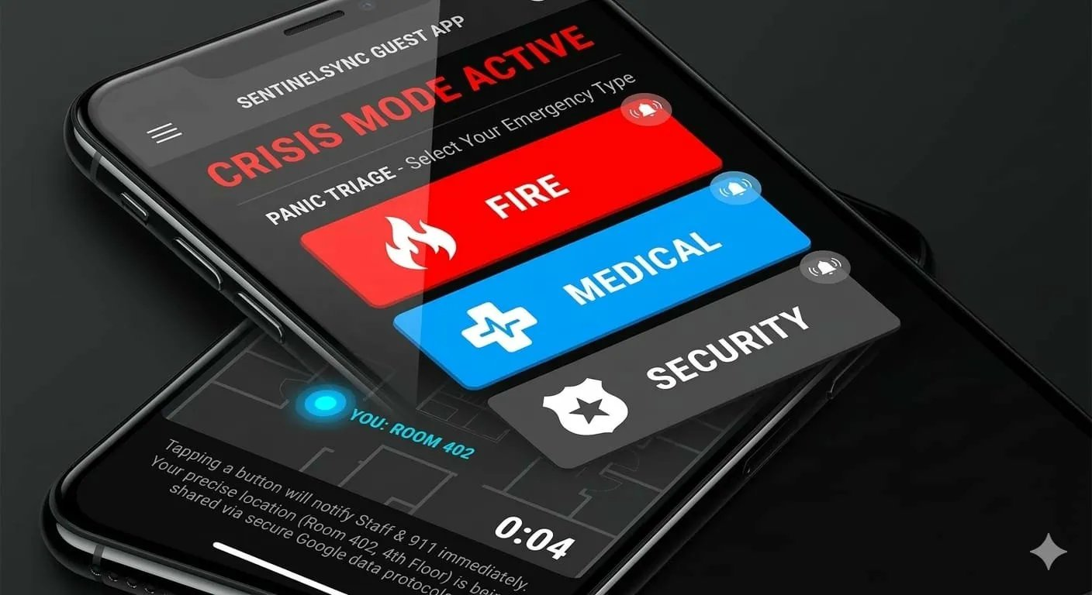
One tap on any category triggers an instant triage sequence powered by Firebase Data Connect for sub-100-millisecond data synchronization. The app simultaneously captures the guest’s precise indoor location (e.g., Room 402, 4th Floor), sends an instant notification to all on-duty staff and 911/emergency services, opens a live communication channel between the guest and the nearest responder, and displays context-specific instructions (“Stay low, move to the nearest stairwell” for fire; “Apply pressure, AED is 30 meters away” for medical). The interface eliminates decision paralysis — the guest makes one choice, and the AI handles everything else. A 0:04 countdown timer confirms the alert was sent, providing psychological reassurance that help is on its way.

Google Technology Stack
- Firebase Data Connect: Sub-100ms real-time data synchronization for instant alert delivery
- Firebase Cloud Messaging: High-priority push notifications bypassing battery optimization on all devices
- Google Maps Indoor API: Precise floor-by-floor guest location capture and display
- Gemini AI: Context-specific emergency instructions generated in the guest’s native language

7.2 Generative AI Emergency Assistant [ENHANCED — 2025–26]
The chatbot provides contextual emergency guidance through natural language interaction. [NEW] Powered by a Generative AI Emergency Assistant built on Google Gemini 2.0 with Retrieval-Augmented Generation (RAG), it supports multimodal input — guests can send text, voice messages, or photos of the emergency for AI-powered scene classification and response. The assistant supports 40+ languages with automatic detection based on the guest’s device locale. Key conversation flows include emergency type identification from text, voice, or image input (fire, medical, security, natural disaster), first aid instructions with adaptive step-by-step questioning, evacuation guidance with personalized real-time route updates, status inquiries about the current incident, and connection requests to speak with a human staff member. The assistant uses streaming token-by-token responses for perceived immediacy and maintains full conversation context across the incident lifecycle.

7.3 Voice-Activated SOS [ENHANCED — 2025–26]
The voice SOS module uses an on-device Whisper-based keyword detection model with multilingual support across 40+ languages. The system listens for configurable trigger phrases such as “Help me,” “Emergency,” or “SOS” in English, Spanish, Mandarin, Arabic, Hindi, French, German, Japanese, Korean, Portuguese, and 30+ additional languages — automatically detecting the guest’s language without prior configuration. To minimize false positives, the system requires a confidence threshold of 85% and performs contextual validation (e.g., checking ambient noise levels and recent movement patterns). Voice activation works even when the screen is off, using a low-power keyword spotting model running entirely on-device with zero network dependency. [NEW] Beyond keyword spotting, the module also supports ambient AI panic detection — classifying distress vocalizations, screams, and impact sounds using spectrogram-based CNNs without recording or transmitting raw audio.

7.4 Indoor Location Tracking
Indoor positioning is achieved through a hybrid approach combining BLE (Bluetooth Low Energy) beacon triangulation for floor and zone-level accuracy (3–5 meter precision), Wi-Fi fingerprinting for building-level positioning, barometric pressure sensors for floor detection in multi-story buildings, and IMU (Inertial Measurement Unit) dead reckoning for continuous tracking between beacon readings. Location data is transmitted every 5 seconds during normal mode and every 1 second during active incidents.

7.5 Evacuation Route Map
The evacuation map renders cached floor plans with real-time route overlays. Routes are calculated by the backend Evacuation Engine using Dijkstra’s shortest path algorithm on a weighted graph representation of the building’s walkways, stairwells, and exits. Edge weights dynamically adjust based on the emergency type (stairwells preferred during fire, interior rooms during earthquake), blocked routes reported by staff or AI analysis, current crowd density from location tracking data, and accessibility requirements for guests with mobility restrictions. The map supports gesture controls (pinch-to-zoom, swipe-to-pan) and includes animated directional arrows guiding the guest along the route.

7.6 Emergency Contacts & Information
The app maintains an offline-accessible directory of property emergency contacts (front desk, security office, nearest hospital), local emergency service numbers (police, fire, ambulance) based on the property’s geographic location, the guest’s personal emergency contact (configurable in settings), and a direct dial button to the property’s 24/7 emergency hotline. All contact information is cached locally for offline access.

Section 8 — Staff Response System

8.1 Incident Alert Interface
Staff alerts are designed for maximum urgency and clarity. When an incident is dispatched to a staff member, the app overrides any current screen with a full-screen alert card displaying the emergency type with color-coded severity (red for critical, orange for high, yellow for medium), exact location with floor, zone, and nearest landmark reference, assigned tasks in priority order, a 15-second countdown timer with accept/decline buttons, and estimated distance and walking time from the staff member’s current position. The alert triggers the device’s maximum volume alarm tone, bypassing Do Not Disturb settings through FCM high-priority channels.

8.2 Guest Location Map
The staff app includes a real-time map showing all guests in the assigned zone. Guests are represented as color-coded dots: green for guests who have acknowledged the evacuation alert, yellow for guests who have not responded, red for guests who triggered an SOS, and gray for guests whose location has not been updated in the last 60 seconds (potential device issues). Staff can tap on any guest marker to see their room number, name (if registered), last known location timestamp, and a navigation route to reach them.

8.3 Emergency Communication Hub
The staff communication system provides three channel types: broadcast channel where the command center pushes updates to all staff simultaneously, team channels for zone-specific or role-specific group communication (e.g., “Floor 14 Evacuation Team”), and direct messaging for private communication between staff members or between staff and the command center. All channels support text, voice notes, photo attachments, and location sharing. Messages are tagged with timestamps and sender roles for audit trail compliance.

8.4 Task Management
Each incident generates a structured task list assigned to staff members based on their role, proximity, and current workload. Tasks follow a defined lifecycle: Assigned, Acknowledged, In Progress, Completed, or Escalated. Staff can update task status with one tap, add notes or photos documenting their actions, and flag tasks for escalation if they encounter obstacles (e.g., “Stairwell B blocked by debris”). The task engine automatically reassigns unacknowledged tasks after the timeout period and generates completion reports for post-incident review.

8.6 Staff “Smart-Response” Wearables [NEW — SIGNATURE FEATURE]
Instead of chaotic radio chatter where critical instructions get lost in noise, CrisisGuard AI delivers precise, role-based mission instructions directly to each staff member’s smartwatch. Every staff member receives a specific “mission” based on their proximity to the incident, their role (security, medical, maintenance), and their training certifications — eliminating the confusion of traditional broadcast radio communication entirely.
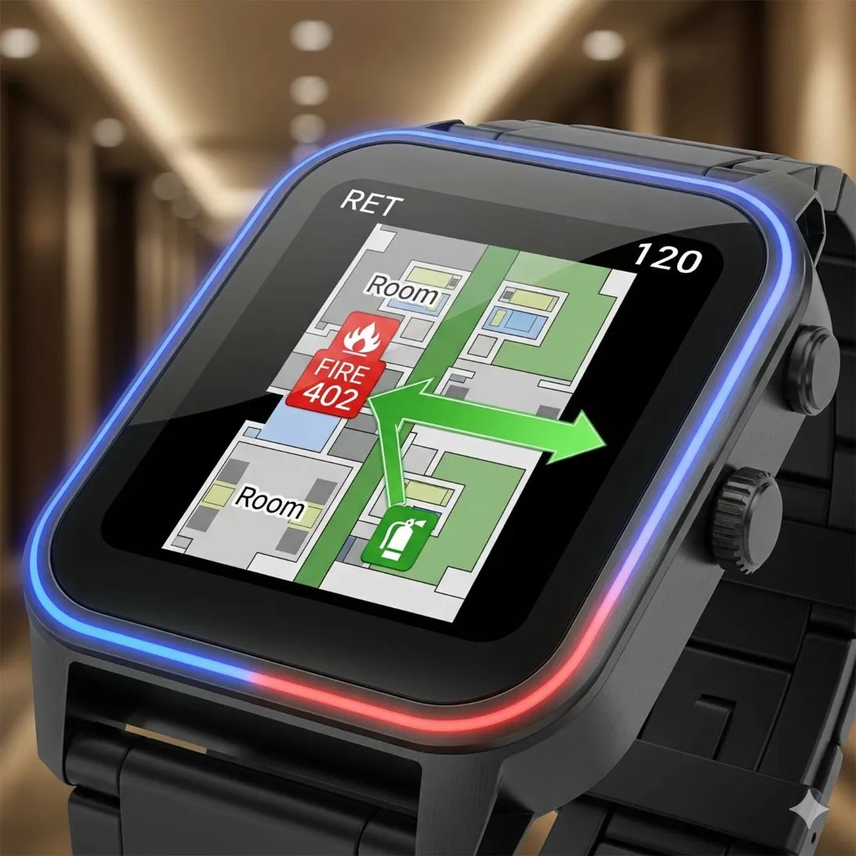

Wearable Interface Design
The smartwatch display is optimized for glance-and-act interaction during high-stress situations. The screen shows a real-time mini-map centered on the staff member’s current position, with the emergency location (e.g., “FIRE 402”) highlighted in a red badge with flame icon and a green directional arrow guiding them to either the incident or the nearest safety equipment (fire extinguisher icon shown in green). The watch face glows with a blue-red border animation for critical alerts, ensuring visibility even in peripheral vision. Room numbers and floor indicators (“RET”, “120”) provide spatial context at a glance.
The wearable supports three interaction modes: a haptic-only silent alert mode for security threats where audible alarms could escalate danger, a voice command mode for hands-free task status updates (“Room 1405 cleared”), and a one-tap acknowledgment for confirming task receipt. All wearable data syncs with the admin command center in real time, providing the incident commander with a live view of every staff member’s location, assigned task, and completion status on the crisis dashboard.

Google Technology Stack
- Firebase Cloud Messaging: Instant high-priority alert delivery to Wear OS smartwatch devices
- Google Maps Indoor API: Floor-by-floor navigation with directional guidance rendered on the watch face
- Wear OS Tiles API: Persistent emergency information displayed without needing to open the full app
- Firebase Realtime Database: Bi-directional sync of task status between wearable and command center

8.5 Evacuation Coordination Tools
Staff members assigned to evacuation duty receive specialized tools including a floor-by-floor room clearance checklist with swipe-to-confirm for each room, a headcount tracker comparing expected occupancy against assembly point check-ins, a walkie-talkie-style push-to-talk feature for hands-free communication, and a route status updater allowing staff to mark passages as clear, partially blocked, or fully blocked, which immediately updates all guest evacuation maps.

Section 9 — Admin Command Center

9.1 Crisis Monitoring Dashboard
The command center dashboard is a multi-panel web interface optimized for large displays (recommended 2–4 monitors or a video wall in the security operations center). The primary panel occupies 60% of the viewport and displays the building’s interactive floor plan with real-time overlays showing guest locations (anonymized dots with color-coding by status), staff positions (labeled markers with role icons), AI detection alerts (flashing icons at camera locations), incident zones (highlighted areas with severity shading), and evacuation route status (green for clear, red for blocked). The dashboard supports multi-property view for portfolio operators, with a property selector and aggregate alert feed.

9.2 Incident Analytics
The analytics module provides both real-time and historical insights. Real-time metrics include active incident count and severity breakdown, average response time for current shift, staff utilization rate and availability, guest evacuation progress percentage, and external service ETA countdown. Historical analytics include monthly incident frequency and trend analysis, response time distributions with percentile breakdowns, staff performance rankings by response speed and task completion, incident type distribution heatmaps by time of day and day of week, and drill performance comparisons against actual incident benchmarks.

9.3 Building Heatmap
The heatmap visualization layer transforms raw location data into an intuitive density map. During normal operations, it shows occupancy patterns useful for staffing optimization and resource allocation. During emergencies, it reveals crowd concentration points that may indicate evacuation bottlenecks. The heatmap uses a WebGL-accelerated rendering pipeline capable of displaying 10,000+ location points at 30fps refresh rate. Color gradients transition from cool blue (low density) through green and yellow to red (high density / danger zone).

9.4 Staff Assignment & Deployment
The staff management panel allows administrators to view all on-duty staff with their current assignment, zone, and status. During incidents, the AI-assisted dispatch engine recommends optimal staff assignments based on proximity, qualification, and current workload. Administrators can accept AI recommendations with one click or manually override assignments. The system maintains a skills matrix for each staff member (CPR certified, fire warden trained, security licensed) to ensure appropriate responder dispatch.

9.5 Communication Logs & Audit Trail
Every action, message, alert, and decision within the platform is logged with millisecond timestamps, actor identification, and contextual metadata. The audit trail is immutable and stored in a separate, append-only database partition for compliance with hospitality safety regulations. Administrators can search, filter, and export communication logs for incident reports, insurance claims, regulatory audits, and legal proceedings. The system generates automated incident summary reports within 15 minutes of incident resolution.

9.6 Real-Time Incident Heatmap [NEW — 2025–26]
The Real-Time Incident Heatmap is a WebGL-accelerated visualization layer that transforms live location, AI detection, and incident data into an intuitive spatial intelligence map updated every 2 seconds. During active crises, the heatmap renders multiple overlapping data layers: guest density concentrations (blue-to-red gradient indicating crowd buildup at chokepoints), AI threat zones (pulsing red overlays at locations where CCTV or audio AI has detected danger), evacuation flow vectors (animated arrows showing aggregate movement direction and speed per corridor), staff coverage gaps (amber zones where no responder is currently deployed), and historical incident hotspots (semi-transparent rings showing prior incident locations for pattern recognition). The heatmap uses GPU-accelerated particle rendering capable of displaying 50,000+ individual location points at 30fps. Administrators can toggle layers on/off, apply time-range filters to replay incident progression, and export heatmap snapshots as evidence attachments. During post-incident review, the heatmap replay mode provides a frame-by-frame reconstruction of crowd movement, enabling identification of evacuation bottlenecks and optimization of future route planning.

9.7 Live Crisis Situation Updates [NEW — 2025–26]
The Live Crisis Situation Updates module provides a continuously streaming incident feed to all stakeholders — guests, staff, and administrators — with role-appropriate detail levels. Guest-facing updates are simplified and action-oriented (“Fire contained to Floor 14. Continue evacuating via Stairwell A. Estimated all-clear: 12 minutes.”), delivered as push notifications and in-app banners every 60 seconds during active incidents. Staff-facing updates include tactical details such as updated task assignments, route status changes, and resource redeployment orders. The admin command center receives a full-fidelity event stream with AI-generated rolling SITREPs (situation reports) aggregating all data sources into concise narrative summaries. All updates are delivered via WebSocket for sub-second latency and cached locally on devices for offline access. The AI-generated SITREP engine uses Gemini to synthesize the last 60 seconds of incident data into a 3–5 sentence executive summary, enabling incoming commanders or shift changes to achieve full situational awareness without reading hundreds of individual log entries.

Section 10 — AI System Design

10.1 CCTV Emergency Detection
The computer vision pipeline processes RTSP video streams from on-property CCTV cameras through a multi-stage analysis pipeline deployed on Vertex AI with GPU-accelerated inference.

10.1.1 Pipeline Architecture
Video frames are sampled at 5 FPS (configurable per camera) and sent to the inference pipeline. Stage 1 uses a lightweight MobileNet-SSD model for scene classification, determining whether the frame contains normal activity or potential anomalies. Frames flagged in Stage 1 proceed to Stage 2, which runs specialized detection models: YOLOv8 fine-tuned for fire and smoke detection with 94% accuracy, a custom-trained model for crowd panic detection analyzing optical flow patterns, pose estimation models detecting fallen persons or aggressive behavior, and object detection for abandoned luggage or weapons. Stage 3 applies temporal analysis, requiring anomaly detection in at least 3 consecutive frames (600ms) before triggering an alert, dramatically reducing false positive rates.

10.1.2 Model Training & Deployment
Models are trained using Vertex AI Training with custom TensorFlow/PyTorch containers. Training data comprises publicly available emergency scenario datasets (COCO, ImageNet), synthetic data generated through Unreal Engine simulation of hospitality environments, and anonymized real-world footage from partner properties (with consent and privacy review). Models are deployed as Vertex AI Endpoints with A/B testing capability for gradual model updates without service disruption.

10.1B The AI “Silent Sentry” [NEW — SIGNATURE FEATURE]
The AI Silent Sentry is a breakthrough ambient intelligence system that detects emergencies through sound analysis — without waiting for any human to press a button or make a call. Using Gemini AI’s multimodal processing capabilities, the system continuously analyzes audio patterns from existing CCTV microphone feeds to identify emergency sound signatures in real time. This is a pure software feature requiring zero additional hardware — it runs entirely on existing camera infrastructure.
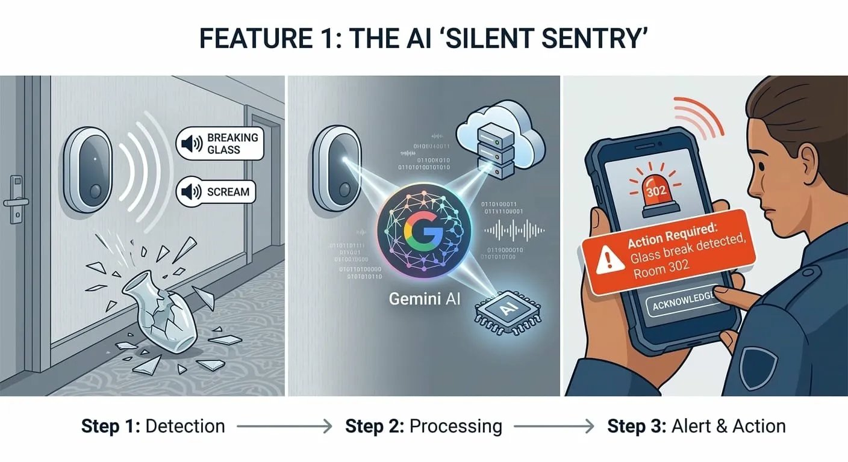

Three-Stage Detection Pipeline
- Step 1 — Detection: Ambient audio from existing hallway and lobby camera microphones is processed through a spectrogram-based CNN classifier. The model is trained to recognize 12 emergency sound categories including glass breaking, screams, gunshots, smoke alarm tones, explosion impacts, and aggressive shouting. Detection occurs within 2 seconds of the sound event with 96% classification accuracy.
- Step 2 — Processing: Detected sound events are sent to Gemini AI for multimodal contextual analysis. The AI correlates the audio detection with simultaneous CCTV visual analysis from the same camera, cross-references the location against the property’s floor plan, and assigns a severity classification. For example, glass breaking in a restaurant during dining hours is classified differently from glass breaking in an empty hallway at 3 AM.
- Step 3 — Alert and Action: Confirmed emergency events trigger an instant alert to the nearest security staff member’s device with the exact room/zone number (e.g., “Glass break detected, Room 302”), the detected sound type, a confidence score, and a one-tap “Acknowledge” button. Unacknowledged alerts escalate automatically after 15 seconds to the next nearest responder.

Google Technology Stack
- Gemini AI: Multimodal audio-visual correlation and contextual severity assessment
- Vertex AI: Custom spectrogram CNN model training and GPU-accelerated real-time inference
- Cloud Pub/Sub: Sub-second event pipeline from detection to staff notification
- Firebase Cloud Messaging: High-priority alert delivery bypassing Do Not Disturb settings

10.2 Voice Distress Recognition
The voice analysis system operates in two modes: keyword spotting for intentional SOS activation and ambient audio analysis for unintentional distress detection (screams, breaking glass, gunshots). The keyword spotting model runs on-device using TensorFlow Lite, consuming minimal battery. Ambient audio analysis processes anonymized audio features (MFCCs, spectral centroids) without recording or transmitting raw audio, preserving privacy. The system achieves 92% accuracy for distress sound classification with a false positive rate below 3% through contextual filtering (e.g., suppressing alerts near entertainment venues or pool areas where screaming is expected).

10.3 Generative AI Crisis Assistant [ENHANCED — 2025–26]
The emergency assistant is powered by Google Gemini 2.0 with a crisis-specific system prompt and Retrieval-Augmented Generation (RAG) grounded in each property’s floor plans, emergency protocols, and real-time incident data. Unlike traditional intent-based chatbots, the Generative AI architecture supports fully multimodal interaction: guests can submit text descriptions, voice messages (auto-transcribed), or photos of the emergency for AI-powered scene classification. The architecture includes a multimodal input processor handling text, audio, and image inputs simultaneously, a RAG retrieval layer fetching property-specific emergency protocols and real-time incident context, a Gemini inference engine generating contextually grounded, emotionally calibrated crisis guidance, a safety-critical output validator ensuring all evacuation directions and medical instructions are verified against the property’s spatial model, and a multilingual output layer supporting 40+ languages with automatic detection and safety-validated translation of directional and medical terminology.

10.4 Anomaly Detection
The anomaly detection engine operates on aggregated video, audio, and behavioral data to identify emerging threats before they become full emergencies. The system uses an ensemble of isolation forest algorithms for detecting unusual patterns in CCTV footage and access logs (e.g., abnormal crowd formations, unusual access card patterns), LSTM (Long Short-Term Memory) networks for time-series prediction of behavioral baselines, detecting deviations from learned normal patterns, and graph neural networks analyzing the spatial relationships between simultaneous AI detections across multiple cameras to distinguish between localized false alarms and building-wide emergencies. Detected anomalies are classified into three tiers: advisory (logged for review), warning (notifies duty manager), and critical (triggers full incident protocol).

10.5 AI Panic Detection [NEW — 2025–26]
The AI Panic Detection module is a 2025–26 state-of-the-art capability that fuses multiple AI signals to identify panic events in real time without relying on physical alarm hardware. The system operates across three detection vectors simultaneously. First, Visual Panic Detection uses transformer-based action recognition models (Video Swin Transformer) to analyze CCTV feeds for crowd stampede patterns, sudden mass movement direction changes, and abnormal running behavior — achieving 96% detection accuracy with under 2-second latency. Second, Acoustic Panic Detection processes ambient audio through Whisper-based spectrogram classifiers trained on distress vocalizations, identifying collective screaming, glass shattering, and explosion-like sounds while filtering out expected venue noise (pool areas, entertainment zones) using venue-specific noise profiles. Third, Behavioral Panic Detection uses on-device accelerometer and gyroscope data from guest smartphones to detect mass movement anomalies — when 15% or more devices in a zone simultaneously show running-speed acceleration patterns, a panic event is confirmed. These three vectors feed into a Bayesian fusion engine that combines confidence scores, requiring at least two corroborating vectors before triggering a P0 alert, dramatically reducing false positives while maintaining sub-3-second detection latency.

10.6 Generative AI Emergency Assistant [NEW — 2025–26]
Replacing the traditional rule-based chatbot approach, the Generative AI Emergency Assistant is powered by Google Gemini 2.0 with a crisis-specific system prompt and Retrieval-Augmented Generation (RAG) grounded in the property’s floor plans, emergency protocols, and real-time incident data. The assistant supports fully multimodal interaction: guests can send text descriptions, voice messages (auto-transcribed via Whisper), or photos of the emergency situation, and the AI responds with contextually grounded guidance in the guest’s native language (40+ languages supported with automatic detection). Key capabilities include real-time situation assessment from uploaded photos (“I see smoke in the hallway” triggers image analysis and location-correlated alerting), personalized evacuation instructions grounded in the guest’s exact indoor position, step-by-step first aid guidance with adaptive questioning (“Is the person breathing?”), and emotional de-escalation responses calibrated for crisis situations. The assistant maintains conversation context across the entire incident lifecycle, remembering prior exchanges and adapting guidance as the situation evolves. All conversations are streamed token-by-token for perceived immediacy, with critical instructions highlighted using structured response formatting.

10.7 AI Incident Summarization [NEW — 2025–26]
The AI Incident Summarization engine generates real-time and post-incident narrative summaries using large language models. During an active crisis, the system produces rolling situation reports (SITREPs) every 60 seconds by aggregating data from all active channels: staff task updates, guest SOS messages, AI detection events, command center decisions, and communication logs. These SITREPs are structured as concise 3–5 sentence summaries with severity assessment, resource deployment status, and recommended next actions — enabling incoming shift commanders or arriving first responders to achieve situational awareness in under 10 seconds. Post-incident, the engine generates comprehensive after-action reports by reconstructing the complete incident timeline, identifying response bottlenecks (e.g., “Floor 8 evacuation delayed by 4 minutes due to stairwell B congestion”), computing key performance metrics, and providing AI-generated recommendations for protocol improvements. Reports are generated within 15 minutes of incident resolution and exported in PDF and DOCX formats for regulatory filing.

10.8 Multilingual AI Emergency Support [NEW — 2025–26]
Hospitality venues serve international guests who may not speak the local language. The Multilingual AI Emergency Support module provides real-time crisis communication in 40+ languages with zero-configuration language detection. The system automatically identifies each guest’s language from their device locale and prior interactions, then delivers all emergency notifications, evacuation instructions, and chatbot responses in that language. Voice-activated SOS supports multilingual keyword detection, recognizing distress phrases in English, Spanish, Mandarin, Arabic, Hindi, French, German, Japanese, Korean, Portuguese, and 30+ additional languages. Staff-to-guest communication is auto-translated in real time using Gemini’s translation capabilities, enabling a Japanese-speaking security guard to communicate seamlessly with a French-speaking guest during evacuation. All translated content undergoes safety-critical validation to ensure emergency instructions maintain accuracy across languages — directional terms (“turn left,” “go down”) are verified against the property’s spatial model to prevent mistranslation of life-critical guidance.

Section 11 — Database Design
The system employs a polyglot persistence strategy using Firebase Firestore for real-time operational data and PostgreSQL for relational analytics and reporting.

11.1 Firestore Collections (Real-Time Data)

Users Collection
Field | Type | Description
uid | string | Firebase Auth UID (primary key)
role | string | guest | staff | admin
displayName | string | Full name
email | string | Email address
phone | string | Phone number with country code
propertyId | string | Currently associated property
locale | string | Preferred language (ISO 639-1)
fcmTokens | array<string> | Push notification device tokens
lastLocation | geopoint | Last known coordinates
lastLocationFloor | number | Last known floor number
status | string | active | evacuating | safe | sos
createdAt | timestamp | Account creation time
updatedAt | timestamp | Last profile update

Emergency Events Collection
Field | Type | Description
eventId | string | Auto-generated unique ID
propertyId | string | Property where event occurred
type | string | fire | medical | security | natural_disaster | hazard
severity | string | critical | high | medium | low
status | string | detected | confirmed | responding | resolved | false_alarm
source | string | ai_cctv | ai_audio | ai_text | guest_sos | staff_report
location | map | { floor, zone, coordinates, description }
detectedAt | timestamp | When system first detected the event
confirmedAt | timestamp | When human operator confirmed
resolvedAt | timestamp | When incident was marked resolved
assignedStaff | array<string> | UIDs of assigned responders
guestCount | number | Estimated guests in affected zone
metadata | map | Source-specific data (AI confidence, camera ID, etc.)

Incident Reports Collection
Field | Type | Description
reportId | string | Auto-generated unique ID
eventId | string | Reference to parent emergency event
authorUid | string | Staff member who authored the report
narrative | string | Detailed incident description
actions | array<map> | Chronological list of actions taken
casualties | map | { injuries: number, fatalities: number, missing: number }
propertyDamage | string | Description of physical damage
attachments | array<string> | Cloud Storage URLs for photos/videos
createdAt | timestamp | Report creation timestamp

11.2 PostgreSQL Schema (Analytics)
The PostgreSQL database mirrors critical Firestore data through Cloud Functions triggers that write to Cloud SQL on every Firestore document change. This enables complex analytical queries without impacting real-time Firestore performance. Key tables include response_metrics (tracking time-to-acknowledge, time-to-resolve, and staff response efficiency), evacuation_analytics (recording guest movement patterns and bottleneck identification), and system_health_logs (monitoring camera uptime, AI pipeline latency, and notification delivery rates).

Section 12 — Alert Pipeline
The alert pipeline is the system’s most latency-critical component. Every millisecond of delay between emergency detection and notification delivery directly impacts safety outcomes. The pipeline is engineered for sub-3-second end-to-end latency from detection to notification delivery.

12.1 Pipeline Stages

Stage 1: Event Ingestion (Target: <100ms)
Emergency events enter the pipeline through one of four ingestion endpoints: the Guest SOS API receiving mobile app submissions, the AI Detection webhook receiving CCTV and audio analysis results, the Multimodal AI Gateway receiving image, voice, and text-based emergency reports, and the Staff Report API receiving staff-initiated incident reports. Each endpoint performs input validation, rate limiting (to prevent DDoS or accidental spam), and writes the raw event to a Cloud Pub/Sub topic for downstream processing.

Stage 2: Event Processing (Target: <200ms)
The Alert Processing Service subscribes to the raw event topic and performs deduplication (preventing multiple alerts for the same incident from different sources), severity classification using a rules engine combined with ML-based severity prediction, geospatial correlation (determining which zones and guests are affected), and event enrichment with property context (floor plans, occupancy data, staff assignments). Processed events are published to the “confirmed-alerts” topic.

Stage 3: Notification Dispatch (Target: <500ms)
The Notification Service consumes confirmed alerts and executes parallel dispatch across multiple channels: Firebase Cloud Messaging for mobile push notifications to all affected guests and assigned staff (high priority, bypasses battery optimization), WebSocket broadcast to connected admin dashboard clients, SMS dispatch via Twilio for guests without the app installed or with low battery, email notification to property management and corporate contacts, and API call to external emergency services integration endpoint. Each notification channel operates independently with its own retry logic and failure handling.

Stage 4: Acknowledgment Tracking (Continuous)
The system tracks notification delivery and acknowledgment status for every recipient. Unacknowledged staff alerts escalate after 15 seconds. Unacknowledged guest notifications trigger an automated phone call via Twilio Voice API after 60 seconds. The command center dashboard displays real-time notification delivery statistics showing sent, delivered, read, and acknowledged counts.

12.2 Alert Priority Levels
Priority | Examples | Response SLA | Notification Channels
P0 — Critical | Active fire, active shooter, structural collapse | <30 seconds | All channels simultaneously + external services
P1 — High | Medical emergency, bomb threat, severe weather | <60 seconds | Push + SMS + WebSocket + command center
P2 — Medium | Suspicious package, minor injury, elevator entrapment | <5 minutes | Push + WebSocket + assigned staff only
P3 — Low | Minor safety hazard, noise complaint, equipment malfunction | <15 minutes | WebSocket + duty manager notification

Section 13 — Real-Time Communication Architecture

13.1 WebSocket Architecture
The real-time communication layer uses Socket.IO deployed on a dedicated GKE node pool with sticky sessions enabled via Nginx Ingress. The architecture supports three connection types:
- Persistent Connections: Staff and admin clients maintain always-on WebSocket connections. Connection health is monitored via 25-second heartbeat intervals with automatic reconnection using exponential backoff (1s, 2s, 4s, 8s, max 30s).
- On-Demand Connections: Guest clients establish WebSocket connections only during active incidents, reducing server load during normal operations. Connection upgrade is triggered by FCM push notification.
- Fallback Transport: Socket.IO automatically falls back to HTTP long-polling when WebSocket connections are blocked by corporate firewalls or restrictive network configurations.

13.2 Channel Architecture
WebSocket messages are organized into namespaces and rooms for efficient routing:
- Property Namespace: All connections for a single property share a namespace, enabling property-wide broadcasts.
- Incident Rooms: Each active incident creates a dedicated room. Staff assigned to the incident join the room automatically. The command center subscribes to all incident rooms.
- Zone Rooms: Guests are auto-joined to zone rooms based on their indoor location, enabling floor-specific or zone-specific evacuation instructions.
- Direct Channels: One-to-one communication between any two users, used for staff-to-guest outreach and command center-to-responder directives.

13.3 Message Types
Message Type | Direction | Payload | Priority
alert.new | Server → Client | Incident details, severity, instructions | Critical
alert.update | Server → Client | Updated status, new instructions | High
location.update | Client → Server | Coordinates, floor, timestamp | Normal
task.assign | Server → Staff | Task details, location, deadline | High
task.status | Staff → Server | Task ID, new status, notes | Normal
chat.message | Bidirectional | Text, media URL, sender info | Normal
evacuation.route | Server → Guest | Route waypoints, distance, ETA | Critical
heartbeat | Bidirectional | Timestamp, connection metadata | Low

13.4 Scaling Strategy
WebSocket connections are inherently stateful, requiring careful horizontal scaling design. The system uses Redis Pub/Sub as a cross-instance message broker, ensuring messages published on any Socket.IO instance are delivered to clients connected to other instances. Each Socket.IO instance handles up to 10,000 concurrent connections. Auto-scaling adds instances when average connection count exceeds 7,000 (70% capacity). Connection state is stored in Redis, enabling seamless failover if an instance terminates.

Section 14 — Security & Privacy

14.1 Data Protection
All data is encrypted at rest using AES-256 encryption managed by Google Cloud KMS (Key Management Service). Data in transit is protected by TLS 1.3 for all API and WebSocket communications. Sensitive fields (guest names, phone numbers, room assignments) are encrypted at the application level using envelope encryption before storage in Firestore, providing an additional layer of protection beyond GCP’s default encryption.

14.2 Authentication & Authorization
Firebase Authentication provides the identity layer with support for email/password, phone number OTP, social login (Google, Apple), and anonymous authentication for guests who prefer not to create accounts. Role-based access control (RBAC) is enforced through Firebase Custom Claims embedded in JWT tokens. Three role tiers exist: guest (read own data, trigger SOS), staff (read zone data, update tasks, communicate), and admin (full system access, configuration, analytics). API endpoints validate JWT tokens and role claims on every request through middleware.

14.3 Location Privacy
Guest location data is the system’s most sensitive information. Privacy safeguards include explicit opt-in consent for location sharing during app onboarding, location data is associated with anonymized identifiers, not personal information, during normal operations, location data retention is limited to 24 hours with automatic purging via Cloud Functions scheduled jobs. During active incidents, location data is retained for 90 days for regulatory compliance and incident investigation. Guests can revoke location permissions at any time, though this disables personalized evacuation routing. The admin dashboard displays anonymized location dots—staff can only see guest identity information when actively assigned to assist that specific guest.

14.4 Secure Communication
All WebSocket messages are transmitted over WSS (WebSocket Secure) with TLS 1.3. Message payloads containing sensitive information (guest names, room numbers) are additionally encrypted using the recipient’s public key, implementing end-to-end encryption for direct messages. Communication logs are stored in tamper-evident append-only storage with cryptographic hash chains for audit integrity verification.

14.5 Compliance
The platform is designed for compliance with GDPR (General Data Protection Regulation) for European properties including data subject access requests, right to erasure, and data portability. CCPA (California Consumer Privacy Act) compliance is maintained for US properties. PCI DSS considerations apply if payment processing is integrated for premium emergency insurance features. Local hospitality safety regulations are addressed through configurable compliance modules per jurisdiction.

Section 15 — Scalability Design

15.1 Scaling Targets
Metric | Target Capacity | Scaling Mechanism
Properties | 1,000+ simultaneously managed | Multi-tenant Firestore with property-level sharding
Concurrent Users | 1,000,000+ | GKE auto-scaling + Redis connection pooling
Alerts per Second | 10,000+ | Cloud Pub/Sub with parallel consumer groups
WebSocket Connections | 500,000+ | Horizontal Socket.IO scaling with Redis adapter
AI Inference Requests | 1,000/second | Vertex AI auto-scaling endpoints with GPU pools
Location Updates | 100,000/second | Redis streams with batch Firestore writes
Notification Delivery | 50,000/second | FCM topic messaging + parallel SMS dispatch

15.2 Horizontal Scaling Architecture
Every microservice is designed as a stateless, horizontally scalable unit. Session state is externalized to Redis, database connections are pooled through PgBouncer for PostgreSQL and managed by Firestore’s SDK for NoSQL operations. GKE Horizontal Pod Autoscaler (HPA) scales each service independently based on custom metrics: the Alert Processing Service scales on Pub/Sub message backlog depth, the Notification Service scales on pending notification queue length, the WebSocket Service scales on active connection count, and the AI Gateway scales on inference request latency. Cluster Autoscaler adds GKE nodes when pod scheduling fails due to insufficient resources, with a maximum scale-out of 200 nodes per regional cluster.

15.3 Multi-Region Deployment
For global hospitality chains, the platform supports multi-region deployment with regional GKE clusters in Americas (us-central1), Europe (europe-west1), and Asia-Pacific (asia-southeast1). Each region operates independently for data sovereignty compliance, with cross-region replication for corporate analytics dashboards. Traffic routing uses Cloud DNS with geolocation-based resolution, directing users to the nearest regional cluster.

Section 16 — Integration with Emergency Services

16.1 Integration Architecture
CrisisGuard AI connects with external emergency services through a dedicated Emergency Services Gateway that supports multiple integration protocols:
- CAD Integration: Computer-Aided Dispatch systems used by police and fire departments receive structured incident data via standardized NIEM (National Information Exchange Model) format over secure HTTPS endpoints.
- NG911 Compatibility: The platform supports Next Generation 911 protocols, enabling rich data delivery (location, photos, video) to emergency call centers that have upgraded to NG911 infrastructure.
- Direct API Integration: For emergency services with modern dispatch systems, CrisisGuard AI provides a RESTful API for bidirectional communication, allowing dispatchers to receive incident updates and send ETA information back to the command center.
- Telephony Fallback: For jurisdictions without digital integration, the system initiates automated phone calls via Twilio Voice API with text-to-speech incident summaries, falling back to the universal 911/112/999 calling convention.

16.2 Data Shared with First Responders
When an incident triggers external service notification, the following data package is transmitted: property name and address with GPS coordinates, incident type and severity classification, specific location within the property (building, floor, zone), estimated number of people in the affected area, current status of the incident (spreading, contained, resolved), building floor plans in standard CAD format, real-time occupancy data for triage prioritization, and any available CCTV snapshots or AI-generated incident assessments relevant to the incident. All shared data is logged for legal and regulatory audit purposes.

16.3 First Responder “X-Ray” Dashboard [NEW — SIGNATURE FEATURE]
Firefighters and police typically arrive at emergencies blind — with no knowledge of the building layout, fire location, or where people are trapped. The X-Ray Dashboard gives first responders a “God View” of the building on their rugged tablet before they even enter the structure, potentially saving minutes of critical search time and enabling targeted, life-saving rescue operations.
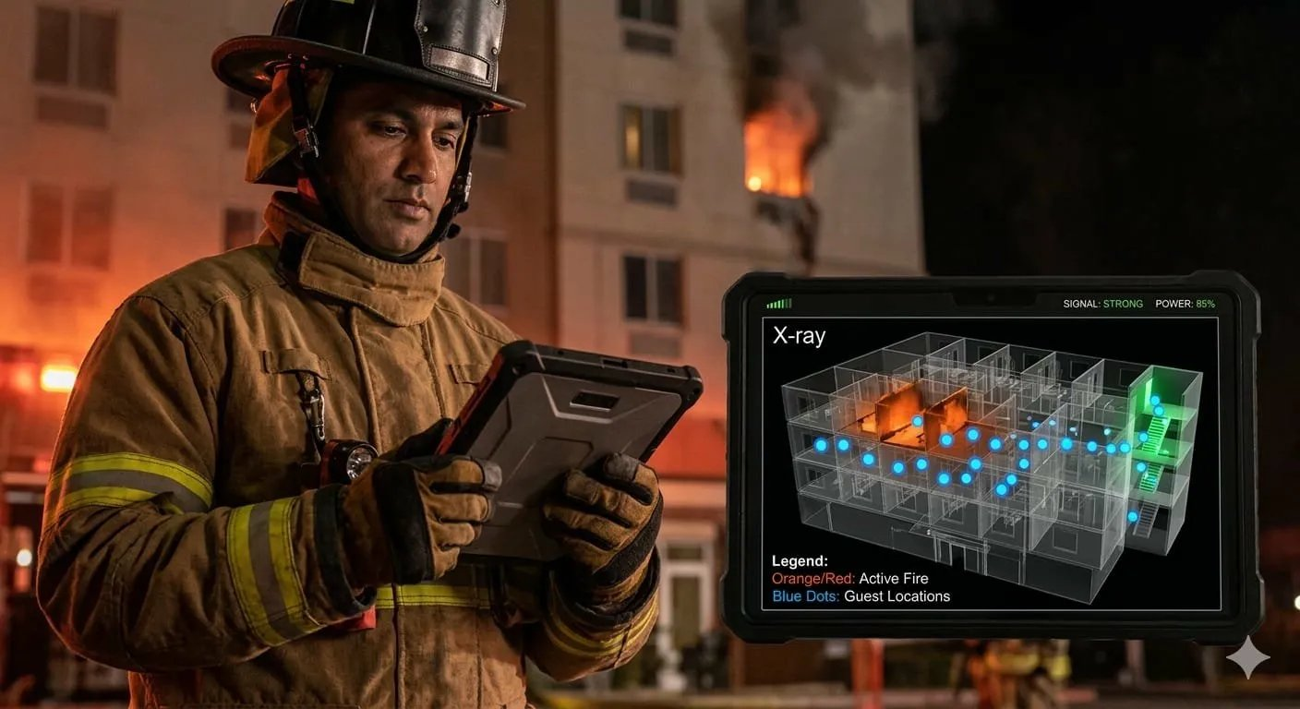

3D X-Ray Visualization
The X-Ray view renders a 3D transparent model of the building where floors appear as semi-transparent layers, allowing responders to see through the entire structure at a glance. Three critical data layers are overlaid simultaneously: Active fire/hazard zones are shaded in pulsating orange-red, showing the fire’s exact location and estimated spread direction based on AI prediction models. Guest locations appear as bright blue pulse dots, each representing a device that has reported a location update in the last 60 seconds. Unresponsive dots (gray) indicate guests whose devices have stopped reporting — these are automatically prioritized for search and rescue. Green indicators mark safe exit routes and cleared stairwells.
The dashboard header displays SIGNAL: STRONG and POWER: 85% indicators confirming that the live data feed is reliable. A real-time legend shows total occupancy, evacuation progress percentage, and the number of unaccounted guests by floor. First responders can tap any floor to zoom into a detailed 2D floor plan with room-level precision, enabling surgical rescue operations rather than blind floor-by-floor sweeps.

Google Technology Stack
- Google Maps Platform + WebGL: 3D building model rendering with real-time multi-layer data overlays
- Firebase Realtime Database: Live guest and staff location synchronization at 1-second intervals
- Cloud Functions: Automated secure data package assembly and sharing with authorized first responder devices
- Vertex AI: Fire spread prediction model estimating hazard zone expansion over the next 5–15 minutes

Section 17 — Evacuation Guidance System

17.1 Graph-Based Routing Engine
The evacuation engine represents each property as a weighted directed graph. Nodes represent physical locations: rooms, corridor intersections, stairwell landings, elevator lobbies, and exit points. Edges represent walkable paths between nodes with weights determined by physical distance, estimated traversal time (adjusted for crowd density), accessibility rating (wheelchair-accessible routes have lower weights for guests with mobility needs), and current status (clear, partially blocked, fully blocked). The engine runs a modified Dijkstra’s algorithm that finds the shortest safe path from each guest’s current location to the nearest viable exit, avoiding the emergency zone and any blocked routes.

17.2 Dynamic Route Adaptation
Routes are recalculated every 10 seconds during active evacuations. When a staff member reports a blocked route, the graph edge weight is set to infinity, and all affected guest routes are immediately recalculated and pushed via WebSocket. The system monitors crowd density at chokepoints (stairwells, corridors, exits) and redistributes guest flow to prevent bottlenecks by assigning alternative routes when primary routes exceed capacity thresholds. For multi-story buildings, the engine staggers floor-by-floor evacuation to prevent stairwell overcrowding, evacuating the fire floor and floors immediately above first, followed by remaining floors in descending order.

17.3 Assembly Point Management
Each property configures one or more assembly points with maximum capacity. The system assigns guests to assembly points based on proximity and current utilization. As guests arrive at assembly points and check in (via app button, QR code scan, or staff manual check-in), the command center displays real-time headcount comparisons against expected occupancy. Unaccounted guests are flagged and their last known locations are highlighted on the staff map for search and rescue prioritization.

17.4 Smart Evacuation Route Generation [NEW — 2025–26]
The Smart Evacuation Route Generation engine advances beyond traditional shortest-path algorithms by incorporating AI-driven predictive modeling and real-time crowd simulation. The system uses a reinforcement learning agent trained on thousands of simulated evacuation scenarios to optimize not just individual routes but global evacuation flow across the entire property simultaneously. Key innovations include: Predictive Congestion Avoidance — the AI anticipates bottleneck formation 30–60 seconds before they occur by modeling crowd flow dynamics and proactively redistributes guest routes to prevent chokepoint saturation; Personalized Route Adaptation — routes are tailored to individual guest profiles including mobility restrictions, floor location, and group size (families with children receive wider-corridor routes avoiding steep stairwells); Emergency-Type-Aware Routing — the engine applies emergency-specific routing policies (fire: avoid smoke zones and route away from fire floor; earthquake: prefer exterior exits over interior corridors; security threat: route away from threat vector and toward secured lockdown zones); and Multi-Exit Load Balancing — the AI distributes evacuating guests across all available exits proportionally to exit capacity, preventing dangerous crowding at a single exit point. Routes are recalculated every 5 seconds and pushed to guest devices via WebSocket, with animated turn-by-turn navigation featuring distance countdown, estimated time to safety, and audio guidance in the guest’s language. The engine processes up to 10,000 simultaneous route calculations in under 500ms using GPU-accelerated graph processing on Vertex AI.

17.5 AR “Green Path” Evacuation Navigation [NEW — SIGNATURE FEATURE]
The AR Green Path is a revolutionary augmented reality evacuation guidance system that overlays real-time directional arrows directly onto the guest’s phone camera view, creating a “Living Green Line” that guides them to safety through smoke-filled, dimly lit, or unfamiliar corridors. Unlike static floor maps or generic exit signs, the Green Path adapts dynamically to the live emergency situation — and requires nothing but the guest’s smartphone.
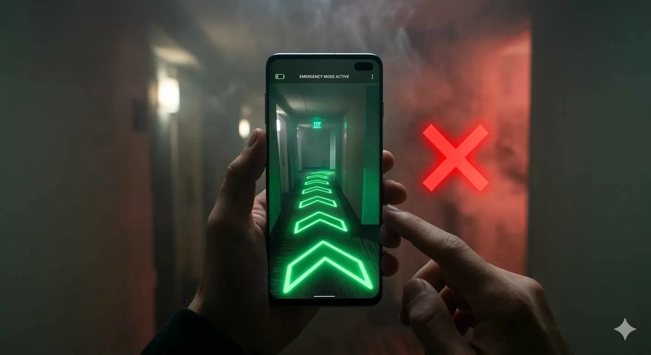

How It Works
When a guest activates “Rescue Mode” in the CrisisGuard app (triggered automatically during confirmed emergencies), the phone’s camera activates and the AR overlay engine renders bright neon-green chevron arrows directly onto the real floor surface using ARCore’s plane detection. The arrows create a continuous animated path from the guest’s current position to the nearest safe exit, with the EXIT sign highlighted at the end of the path. The “EMERGENCY MODE ACTIVE” banner at the top confirms the system is operational.
The system’s most critical capability is dynamic hazard blocking. When the AI evacuation engine detects that a path leads toward an active fire zone, structural damage, or crowd congestion, it displays a large pulsating bright red “X” blocking that direction and automatically reroutes the green path to an alternative safe exit. Route recalculation occurs every 5 seconds based on live data from staff route-status updates, CCTV fire/smoke detection AI, and crowd density analysis from location tracking.

Google Technology Stack
- ARCore: Real-time plane detection and 3D chevron arrow rendering on physical floor surfaces
- Google Maps Indoor API: Floor-level positioning, exit point mapping, and indoor navigation graph
- Vertex AI: Real-time fire/smoke zone detection from CCTV feeding into route blockage decisions
- WebSocket (Firebase): Sub-second route update delivery to all guest devices simultaneously

Section 18 — Failure Handling & Resilience

18.1 Network Failure
The system is designed to degrade gracefully when network connectivity is lost. The mobile app caches floor plans, evacuation routes, and emergency contacts locally using Hive (Flutter) persistent storage. When the device detects network loss, the app switches to offline mode: the SOS button queues the alert locally and transmits it immediately upon reconnection, cached evacuation routes are displayed based on the last known emergency type and location, and a countdown timer shows time since last server contact. For on-property network resilience, the deployment architecture recommends a dedicated emergency Wi-Fi network on a separate VLAN with UPS-backed access points, ensuring connectivity even when the primary guest Wi-Fi fails.

18.2 Power Failure
Building power failures are addressed through UPS (Uninterruptible Power Supply) systems for all on-property networking equipment (minimum 4-hour battery backup), edge computing nodes with battery backup that can operate the AI detection pipeline locally for up to 2 hours without cloud connectivity, existing building fire alarms and safety systems with independent battery power, and the mobile app’s aggressive battery optimization—background location updates switch from GPS to cell tower triangulation, reducing power consumption by 80%. The cloud infrastructure is unaffected by on-property power failures, as all backend services run on GCP with multi-zone availability guarantees.

18.3 Offline Emergency Alerts
When both network and cloud connectivity are lost, the system falls back to a mesh networking mode using Wi-Fi Direct and Bluetooth peer-to-peer connections between guest and staff devices. The mesh network propagates SOS alerts device-to-device within a 30-meter radius, creating a local alert network that functions without any infrastructure. Staff devices with mesh relay capability can bridge alerts to the nearest network-connected device, which then forwards the accumulated alerts to the cloud backend. This mesh fallback is implemented using Google’s Nearby Connections API.

Section 19 — User Experience Design

19.1 Design Principles for Panic Situations
Emergency UX design fundamentally differs from conventional app design. Under extreme stress, cognitive capacity decreases by up to 80%, fine motor control deteriorates, and decision-making ability is severely impaired. The CrisisGuard AI interface is designed around these constraints:
- Maximum Contrast: Emergency screens use white text on dark red or black backgrounds, achieving WCAG AAA contrast ratios (minimum 7:1) for readability in smoke-filled or poorly lit environments.
- Oversized Touch Targets: All interactive elements during emergencies are minimum 72x72dp, three times the standard Material Design touch target, accommodating trembling hands and imprecise taps.
- Minimal Decisions: Each emergency screen presents a single clear action. No menus, no navigation, no settings. The user sees one instruction and one button.
- Redundant Communication: Every instruction is delivered through three simultaneous channels: visual (text + icons), audio (text-to-speech with adjustable volume), and haptic (distinct vibration patterns for different alert types).
- Cultural Universality: Icons use universally recognized symbols (ISO 7010 safety signs). Text is auto-translated to the guest’s device language. Directional guidance uses absolute references (“turn left at the ice machine”) rather than compass directions.

19.2 Accessibility
The app complies with WCAG 2.1 Level AA and includes dedicated accommodations for users with disabilities: screen reader compatibility with semantic labels for all emergency elements, hearing-impaired mode replacing audio alerts with full-screen visual flashes and enhanced haptic patterns, motor-impaired mode enabling voice-only interaction for all emergency functions, and cognitive accessibility through simple language (Flesch-Kincaid Grade Level 5 or below for all emergency instructions).

Section 20 — Deployment Architecture

20.1 CI/CD Pipeline
The deployment pipeline uses Google Cloud Build triggered by GitHub repository events. The pipeline follows a trunk-based development model with the following stages:
- Developer pushes code to a feature branch and creates a pull request.
- Cloud Build automatically runs unit tests, linting, and static analysis (SonarQube).
- Upon PR approval and merge to main, Cloud Build builds Docker images and pushes to Artifact Registry.
- Images are deployed to the staging GKE cluster for integration testing.
- Automated integration tests and load tests run against the staging environment.
- Upon passing all tests, a manual approval gate releases the deployment to production.
- Production deployment uses rolling updates with canary releases (10% traffic for 30 minutes before full rollout).
- Automated rollback triggers if error rate exceeds 1% or latency exceeds P99 thresholds during canary phase.

20.2 Infrastructure as Code
All GCP infrastructure is defined using Terraform modules stored in a dedicated infrastructure repository. Resources include GKE cluster configuration (node pools, autoscaling policies, network policies), Cloud SQL instances with read replicas and backup schedules, Pub/Sub topics and subscriptions with dead-letter queue configuration, IAM roles and service account bindings, Cloud Monitoring alerting policies and dashboards, and Firebase project configuration (Firestore indexes, security rules, FCM setup).

20.3 Environment Architecture
Environment | Purpose | Infrastructure | Data
Development | Local development and unit testing | Docker Compose with emulators | Synthetic test data
Staging | Integration testing and QA | Reduced GKE cluster (3 nodes) | Anonymized production mirror
Production | Live system serving real users | Full GKE cluster with auto-scaling | Real operational data
DR (Disaster Recovery) | Failover for production outages | Cross-region standby cluster | Replicated production data

Section 21 — Testing Strategy

21.1 Unit Testing
Every microservice maintains a minimum 80% code coverage with unit tests. The testing framework stack includes Jest for Node.js services, Pytest for Python/FastAPI services, and Flutter Test for mobile applications. Unit tests focus on business logic validation (alert severity classification, evacuation route calculation), input validation and error handling, database query correctness with mocked data stores, and authentication and authorization logic. Tests run automatically on every pull request via Cloud Build and must pass before merge.

21.2 Integration Testing
Integration tests validate cross-service interactions using a dedicated staging environment. Key integration test scenarios include end-to-end alert pipeline testing (SOS submission through notification delivery), WebSocket connection lifecycle (connect, subscribe, receive, disconnect, reconnect), AI pipeline integration (video frame submission through alert generation), and database consistency between Firestore and PostgreSQL synchronization. Integration tests use Testcontainers for database dependencies and mock external services (Twilio, FCM) to avoid side effects.

21.3 Stress Testing
The system undergoes regular stress testing using Locust (Python-based load testing) to validate performance under crisis-level load. Stress test scenarios include simultaneous SOS from 10,000 guests within 30 seconds (simulating a building-wide earthquake trigger), 50,000 concurrent WebSocket connections with 1,000 messages per second, AI inference pipeline with 500 simultaneous CCTV streams, and notification dispatch to 100,000 devices within 60 seconds. Performance benchmarks require alert pipeline end-to-end latency under 3 seconds at P99, WebSocket message delivery under 500ms at P99, API response time under 200ms at P95, and zero message loss during scaling events.

21.4 Emergency Simulation Testing
The platform includes a built-in drill mode that simulates realistic emergency scenarios without triggering actual emergency service notifications. Drill features include configurable emergency scenarios with scripted event sequences, simulated guest and staff behavior using agent-based modeling, real-time performance measurement during drill execution, automated drill reports comparing response times against benchmarks, and the ability to run drills during off-peak hours without disrupting normal operations. Drills are recommended monthly for each property, with results feeding into staff training programs and system optimization.

Section 22 — Implementation Roadmap

Phase 1: Foundation (Weeks 1–4)
- Set up GCP project, enable required APIs (Vertex AI, Maps, FCM, Cloud SQL)
- Initialize Firebase project with Authentication, Firestore, and Cloud Messaging
- Create Flutter project with BLoC architecture, set up CI/CD with Cloud Build
- Build authentication flows (guest registration, staff login, admin portal access)
- Design and implement Firestore security rules and database schema
- Deploy basic Node.js API gateway on Cloud Run

Phase 2: Core Alert System (Weeks 5–8)
- Implement SOS button with location capture and submission flow
- Build Alert Ingestion Service with Pub/Sub integration
- Implement Notification Service with FCM push and SMS fallback (Twilio)
- Create WebSocket server for real-time alert broadcasting
- Build staff alert dashboard with acknowledge/decline workflow
- Implement incident lifecycle management (create, assign, escalate, resolve)

Phase 3: Intelligence Layer (Weeks 9–12)
- Train and deploy CCTV fire/smoke detection model on Vertex AI
- Implement voice distress detection with on-device keyword spotting
- Build Generative AI emergency assistant using Gemini 2.0 with RAG and multimodal input support
- Implement anomaly detection engine for multimodal AI data analysis
- Integrate AI detection outputs with alert ingestion pipeline

Phase 4: Evacuation & Coordination (Weeks 13–16)
- Implement indoor positioning system with BLE beacon integration
- Build evacuation routing engine with dynamic graph-based pathfinding
- Create interactive evacuation maps in guest and staff apps
- Implement assembly point management and headcount tracking
- Build admin command center with heatmap, staff deployment, and communication hub

Phase 5: Hardening & Launch (Weeks 17–20)
- Conduct stress testing with Locust (10,000+ concurrent users)
- Implement offline mode with mesh networking fallback
- Security audit including penetration testing and OWASP compliance review
- Emergency services integration testing with local fire/police departments
- Deploy to production with canary release strategy
- Conduct full-scale emergency drill simulation at pilot property

Section 23 — Antigravity AI Development Platform Guide
This section provides a modular implementation structure compatible with the Antigravity AI development platform, breaking the project into independently deployable modules with clear interfaces and dependencies.

Module 1 — Authentication & User Management

Scope
Complete user lifecycle management including registration, login, role assignment, and session management for all three user roles.

Components
- Firebase Auth configuration with email, phone, and anonymous providers
- Custom claims middleware for RBAC (guest, staff, admin roles)
- User profile Firestore collection with role-specific fields
- JWT validation middleware for API endpoints
- Flutter auth screens (login, register, role selection, profile setup)

API Endpoints
POST /auth/register, POST /auth/login, GET /auth/profile, PUT /auth/profile, POST /auth/assign-role (admin only)

Module 2 — Emergency Alert System

Scope
End-to-end alert pipeline from SOS trigger through notification delivery.

Components
- SOS trigger UI component (Flutter) with one-tap and long-press modes
- Alert Ingestion API (FastAPI) with validation and Pub/Sub publishing
- Alert Processing Service with severity classification and deduplication
- Notification Dispatcher with FCM, SMS (Twilio), and WebSocket channels
- Incident lifecycle state machine (detected → confirmed → responding → resolved)

Dependencies
Module 1 (Authentication) must be completed before this module.

Module 3 — Real-Time Tracking & Communication

Scope
Indoor positioning, location sharing, and real-time communication channels.

Components
- BLE beacon integration for indoor positioning (Flutter plugin)
- Location update service with Firestore GeoPoint writes
- Socket.IO server with Redis adapter for horizontal scaling
- Chat system with broadcast, team, and direct channels
- Push-to-talk voice messaging implementation

Dependencies
Module 1 (Authentication) and Module 2 (Alert System) must be completed.

Module 4 — Admin Dashboard

Scope
Web-based command center for property administrators and security operations center.

Components
- Next.js project with TypeScript and Tailwind CSS setup
- Real-time incident feed with Socket.IO client integration
- Interactive building map with guest/staff location overlays (Google Maps JS API)
- Staff assignment and dispatch panel with drag-and-drop task allocation
- Incident analytics dashboard with Chart.js visualizations
- Communication log viewer with search and export functionality

Dependencies
Modules 1, 2, and 3 must be completed before this module.

Module 5 — AI Detection System

Scope
All AI/ML components including computer vision, audio analysis, chatbot, and anomaly detection.

Components
- CCTV frame extraction service with RTSP stream processing
- Fire/smoke detection model training pipeline (Vertex AI + TensorFlow)
- Voice distress classification model with on-device TFLite deployment
- Generative AI crisis assistant with Gemini 2.0, RAG pipeline, and multimodal input processing
- Anomaly detection engine with isolation forest and LSTM models
- AI Gateway API routing requests to appropriate Vertex AI endpoints
- [NEW] AI Panic Detection module with multi-vector fusion (visual + acoustic + behavioral)
- [NEW] Generative AI Emergency Assistant powered by Gemini 2.0 with multimodal input (text, voice, image)
- [NEW] AI Incident Summarization engine for real-time SITREPs and post-incident reports
- [NEW] Multilingual AI Support with 40+ language detection and safety-critical translation validation

Dependencies
Module 2 (Alert System) for pipeline integration; Module 1 for authentication.

Module 6 — Emergency Response Workflow

Scope
Evacuation guidance, staff coordination, emergency services integration, and post-incident reporting.

Components
- Evacuation routing engine with weighted graph pathfinding (Python + NetworkX)
- [NEW] Smart Evacuation Route Generation with RL-based predictive congestion avoidance and multi-exit load balancing
- Dynamic route recalculation service with WebSocket push updates
- Assembly point check-in system with QR code and app-based check-in
- Emergency services gateway with CAD/NG911 integration
- Post-incident report generator with automated timeline reconstruction
- Drill mode simulator for testing without external service activation

Dependencies
All previous modules (1–5) must be completed.

Section 24 — Future Improvements

24.1 Drone Response System
Future iterations of CrisisGuard AI will integrate autonomous drone deployment for emergency scenarios. Drones stationed on hotel rooftops can be automatically dispatched to provide aerial surveillance of the emergency zone, delivering real-time video feeds to the command center and first responders. Medical delivery drones can transport AEDs, first aid kits, or emergency medication to remote areas of large properties (resorts, cruise ships) faster than human runners. Search and rescue drones equipped with thermal cameras can locate trapped guests in smoke-filled or structurally compromised areas. The drone control system will integrate with the existing AI pipeline, using computer vision for autonomous navigation and obstacle avoidance within the property’s airspace.

24.2 Wearable Emergency Devices
Integration with wearable devices expands the system’s detection and alert capabilities. Smartwatch SOS triggers (Apple Watch, Wear OS) allow guests to send alerts from their wrist with a simple gesture, valuable when reaching for a phone is impractical. Health monitoring wearables can detect abnormal heart rates, falls, or loss of consciousness and automatically trigger medical SOS alerts. Staff wearables can include smart badges with embedded panic buttons, providing a discreet SOS mechanism that does not require reaching for a phone. Property-issued wristbands for guests (common in resorts and cruise ships) can incorporate BLE beacons for more accurate indoor positioning and NFC for assembly point check-in.

24.3 Smart Building Integration
Deep integration with smart building infrastructure unlocks automated physical responses to emergencies. Automated door lock/unlock systems can open fire exits and lock entry points during security threats based on commands from the CrisisGuard command center. Smart elevator control redirects elevators to ground floors and locks them during fire emergencies, preventing guest misuse. Dynamic signage systems (digital displays throughout the property) can switch from advertising to evacuation instructions, displaying floor-specific directional guidance. HVAC integration enables automatic shutdown of air handling units in fire zones to prevent smoke distribution through ventilation systems. Smart lighting can activate emergency pathway lighting, guiding guests along evacuation routes with illuminated floor strips even during power failures (battery-backed LED systems).

24.4 Predictive Analytics
Machine learning models trained on historical incident data can predict emergency risk levels. Temporal risk scoring identifies high-risk periods based on occupancy levels, weather conditions, and local event calendars. Maintenance-predictive models analyze CCTV and operational data to identify pre-failure conditions (overcrowding patterns, deteriorating safety compliance). These predictions enable proactive risk mitigation, such as pre-positioning additional staff during high-risk periods or scheduling preventive inspections before conditions deteriorate into emergencies.

24.5 Digital Twin Emergency Simulation [NEW — 2025–26]
Future iterations will incorporate digital twin technology to create virtual replicas of each property. Using 3D point cloud data from LiDAR scans and architectural blueprints, the digital twin enables high-fidelity emergency simulations where AI agents simulate thousands of guest evacuation scenarios under varying conditions (fire location, blocked exits, power failures, crowd sizes). These simulations run continuously in the background, pre-computing optimal evacuation strategies for every possible emergency scenario, so that when a real incident occurs, the system can instantly retrieve the pre-calculated optimal response rather than computing it in real time. The digital twin also enables immersive VR-based staff training where responders practice evacuation coordination in a photorealistic virtual environment before encountering real emergencies.

24.6 Edge AI and On-Device Intelligence [NEW — 2025–26]
As on-device AI capabilities mature with frameworks like MediaPipe and TensorFlow Lite, future versions of CrisisGuard AI will shift more intelligence to the edge. On-device models will perform real-time emergency scene classification from the guest’s phone camera (identifying fire, smoke, flooding, structural damage), enabling AI-powered emergency detection without any CCTV infrastructure. On-device Whisper-tiny models will provide voice-activated SOS and distress detection entirely offline, with zero network dependency. Federated learning across devices will continuously improve detection models without transmitting raw data to the cloud, preserving guest privacy while building increasingly accurate emergency recognition. This edge-first approach ensures that the platform remains fully functional even in complete network and power failure scenarios, achieving true zero-dependency emergency detection.

Section 25 — Conclusion
CrisisGuard AI represents a paradigm shift in how the hospitality industry approaches emergency management. By replacing fragmented, manual, and reactive safety systems with an intelligent, connected, and proactive platform, this solution addresses the fundamental communication and coordination failures that cost lives during crises in hotels, resorts, airports, cruise ships, and event venues worldwide.
The platform’s three-layer architecture—connecting guests with intuitive mobile safety tools, empowering staff with real-time response coordination, and providing administrators with AI-enhanced command center capabilities—creates a comprehensive safety ecosystem that operates as a unified whole rather than a collection of disconnected systems.
The AI-powered detection capabilities, including CCTV analysis, voice distress recognition, and anomaly detection, shift emergency response from reactive (waiting for human detection) to proactive (machine detection in seconds). Combined with the sub-3-second alert pipeline, personalized evacuation routing, and seamless emergency services integration, the platform dramatically compresses the timeline between emergency onset and coordinated response.
From a technical standpoint, the cloud-native microservices architecture on Google Cloud Platform ensures the system can scale from a single boutique hotel to a global hospitality chain with thousands of properties and millions of users. The offline-capable mobile apps with mesh networking fallback ensure functionality even in the most adverse conditions—precisely when reliable emergency communication is most critical.
The modular implementation roadmap and Antigravity-compatible development guide provide a clear path from concept to production, enabling development teams to build, test, and deploy the system incrementally while maintaining architectural integrity. The 20-week development timeline delivers a production-ready MVP, with the future improvement roadmap (drones, wearables, smart building integration) providing a multi-year product evolution strategy.
In an industry where guest safety is the foundational promise, CrisisGuard AI transforms that promise from passive infrastructure compliance into active, intelligent protection. This system has the potential to set a new global standard for hospitality emergency management, saving lives through the intelligent application of AI, real-time communication, and coordinated human response.

END OF DOCUMENT
CrisisGuard AI — Project Requirement Document v1.0
Prepared for Google Solution Challenge 2025–26

